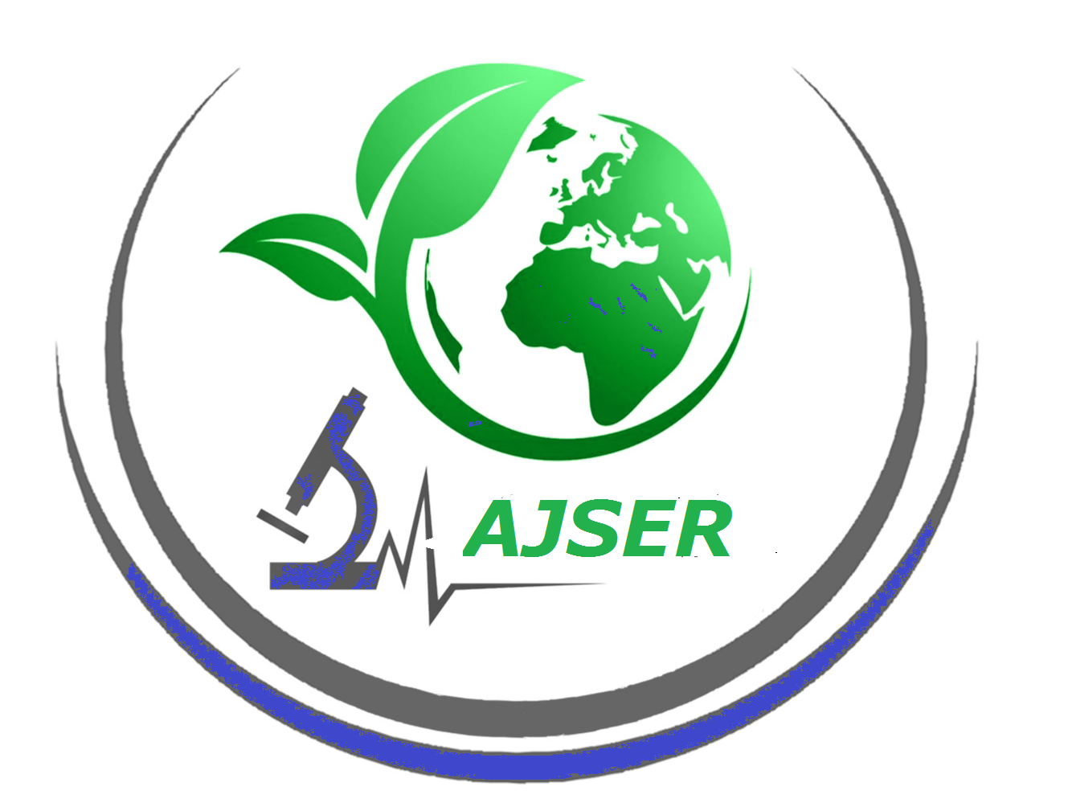

American Journal of Sciences and Engineering Research
E-ISSN: 2348-703X

Title of paper: ____________________________________________________________
__________________________________________________________________
Name of Author(s): __________________________________________________________________
__________________________________________________________________
Mail id: __________________________________________________________________
The undersigned hereby transfer any and all rights in and to the paper including without limitation all copyrights to American Journal of Sciences and Engineering Research. The undersigned hereby represents and warrants that the paper is original and that he/she is the author of the paper, except for material that is clearly identified as to its original source, with permission notices from the copyright owners where required. The undersigned represents that he/she has the power and authority to make and execute this assignment.
This agreement is to be signed by at least one of the authors who have obtained the assent of
the co-author(s) where applicable.
Author's Signature & Date [Corresponding Author (in case many authors)]
________________________________________________________________
Typed or Printed Name
________________________________________________________________
Institution or Company
________________________________________________________________

Send scan copy after sign on it to ajser.editor@gmail.com

